Class Test (F.M.-16)
- A matchstick head has all the followings except
- Antimony trisulfide b) Iron oxide c) Phosphorous sesquisulfide d) Red phosphorous
- Which of the following best explains why water is not used to extinguish oil fires?
a) Water increases the temperature of the fire.
b) Water can spread the oil and make the fire worse.
c) Water reacts violently with oil.
d) Water evaporates too quickly to be useful.
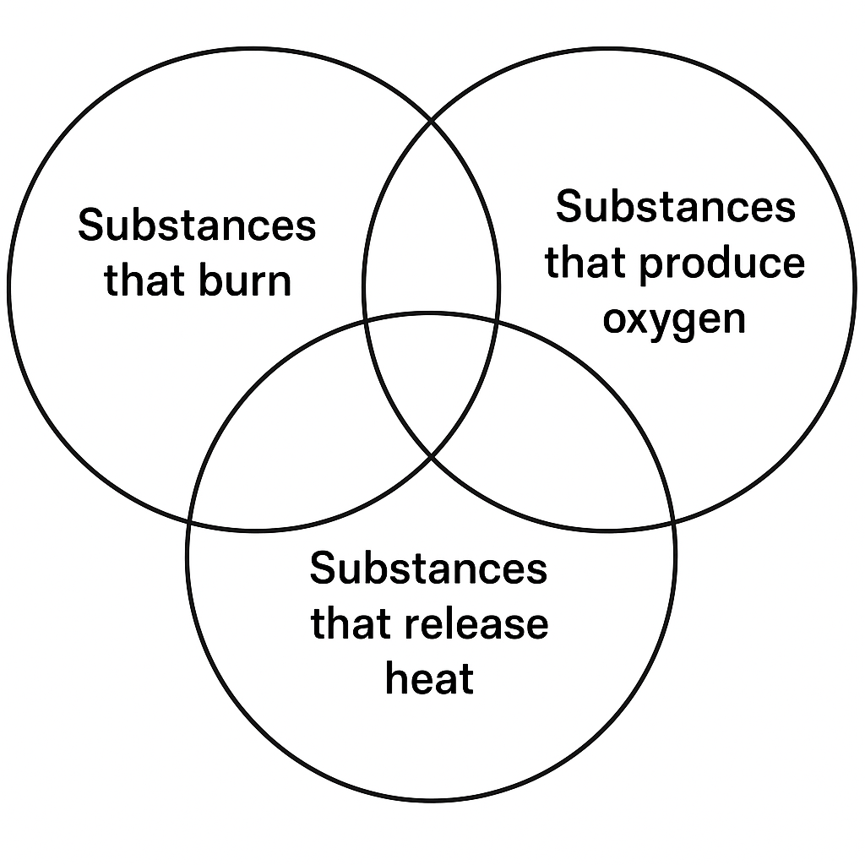
- A Venn diagram shows three circles:
Circle A: Substances that burn
Circle B: Substances that produce oxygen when burned
Circle C: Substances that release heat
Which of the following substances would be present in the overlapping section of all three circles?
a) Potassium chlorate
b) Magnesium oxide
c) Coal
d) Biogas
- Hoe : Weeding :: Thresher : ?
a) Sowing. b) Irrigating. c) Separating grains. d) Ploughing
- Explosion : Sudden combustion :: Candle burning : ?
a) Rapid combustion. b) Incomplete combustion
c) Spontaneous combustion. d) Slow combustion
- Suction cup : Low air pressure inside :: Balloon : ?
a) Low pressure outside. b) High air pressure inside
c) No air inside. d) Same pressure inside and outside
- Assertion (A): When a balloon is inflated, it exerts pressure on its walls.
Reason (R): Gases exert pressure on the walls of their containers.
- Assertion (A): The blue flame of LPG indicates complete combustion.
Reason (R): Incomplete combustion releases harmful carbon monoxide.
- Assertion (A): Sowing seeds at proper depth ensures better germination.
Reason (R): Deeply sown seeds may not germinate properly due to lack of oxygen.
- A farmer planted paddy during the winter season, but the crop failed to grow properly. What is the most probable reason?
a) Paddy requires low water and cold weather.
b) Paddy is a Rabi crop that grows only in winter.
c) Paddy is a Kharif crop and requires warm, wet conditions.
d) Paddy grows best in dry and sandy soil.
- A fire broke out in a house due to an oil spill in the kitchen. Water was poured on the fire but the flames spread rapidly instead of extinguishing. What can be the reason? Which step should have taken instead?
(2)
- An air bubble rising from the bottom to the top of a water container, growing larger. Explain why the size of the bubble increases? (2)

- The following is a fire triangle
Fuel
Heat
Oxygen

Following are three fire extinguishing scenarios:
a) Covering fire with a fire blanket
b) Spraying water
c) Turning off gas supply
Using the Fire Triangle concept, explain which part of the fire triangle is removed in each method to extinguish the fire. (3)
- Despite being a traditional method why Gola is still preferable in some parts of country? (1)

